Personal Reading History Map

In 6th Grade, we will be learning about metaphor and imagery. Writers use metaphor and imagery to add layers of detail to their ideas. In this assignment, we would like you to use the metaphor and imagery of a map as well as a short explanatory essay to show your reading experiences and goals.

Map and Essay Requirements
- The origin. What was your first reading experience? Did somebody read to you? When did you first start reading independently? What did you read when you were younger?
- The journey. As you developed your reading skills, what strengths and challenges did you discover? Which favorite books, authors, or genres did you encounter along the way?
- The destination. What are your reading goals for 6th Grade, Middle School, and beyond? How do you plan to reach those goals? What will you need to get there?

Map Organization and Details (20 pts.)
- Think about the kinds of roads that could represent your reading experiences. (e.g., city street, country lane, coastal highway, path through the mountains, freeway, etc.)
- Think about elements of travel that could represent your reading “journey.” (e.g., an important intersection, a rest stop, traffic lights, speed limits, detours, etc.)

Writing Prompt (30 pts.)
Describe your personal reading history. Include details and examples of early experiences, strengths, challenges and future goals.

Checklist and Rubric

Checklist | Self Review/Edit | Peer Review | Teacher Comments
Did you describe your early reading experiences?
Did you describe your strengths as a reader?
Did you describe your challenges as a reader?
Did you include details about your favorite books, authors or genres?
Did you explain your future reading goals?

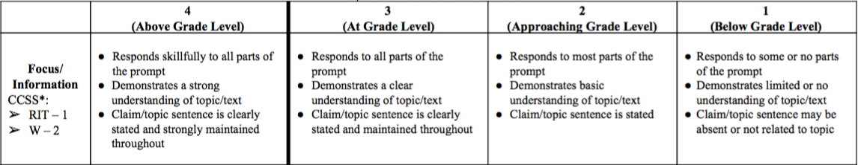
Essay: Rubric score: ______ Points: ______/30
Map: Points: ______/20
Total score: ______/50 Letter grade: ______

